Megan Mosier
CSD-310 Assignment 4.3
April 19, 2026

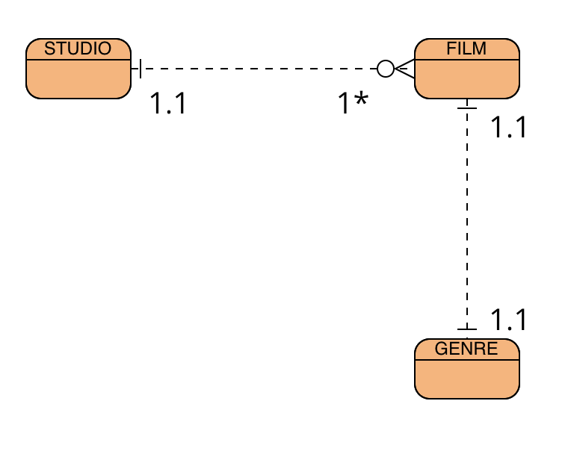

STUDIO
Studio_id; studio_name

GENRE
genre_id; genre_name

FILM
film_id; film_name; film_releaseDate; film_runtime; film_director; studio_id; genre_id

